DIGITAL DESIGN USING HDL LABORATORY (UE18EC206)

EXPERIMENT-8

SIMULATION OF LATCHES AND FLIP-FLOPS USING XILINX VIVADO TOOL

Aim:Write a Verilog code for the following:

D LATCH
module dlatch(e, d, q);
input e;
input d;
output q;
reg q;
always @(e or d)
begin
if (e)
q<=d;
end
endmodule

TEST BENCH
module dlatch_tb;
reg e;
reg d;
wire q;
dlatch uut (.e(e),.d(d),.q(q) );
initial
begin
d = 0;
e = 0;
#5 d=1;
#10 e=1;
#10 d=1;
#20 d=0;
#10 e=1;
end
endmodule

Simulation Waveform

Report Utilization Summary

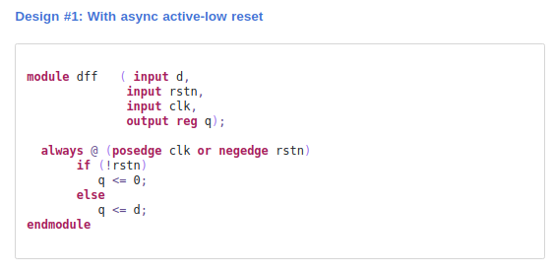

Testbench:
module dff_tb;
reg d,rstn,clk;
wire q;

dff uut(d,rstn,clk,q);

initial
begin
d=0;
rstn=0;
clk=0;
always #10 clk=~clk;

#10 d=1;
#20 rstn=1;
#10 d=0;
#10 d=1;
#40 rst=0;
#10 d=0;
#10 d=1;
end
endmodule

Simulation Waveform

Report Utilization Summary

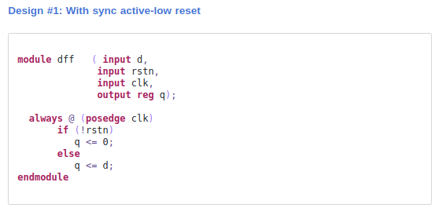

Testbench:
module dff_tb;
reg d,rstn,clk;
wire q;

dff uut(d,rstn,clk,q);

initial
begin
d=0;
rstn=0;
clk=0;
always #10 clk=~clk;

#10 d=1;
#20 rstn=1;
#10 d=0;
#10 d=1;
#40 rst=0;
#10 d=0;
#10 d=1;
end
endmodule

Simulation Waveform

Report Utilization Summary

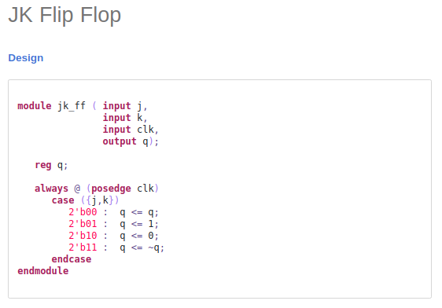

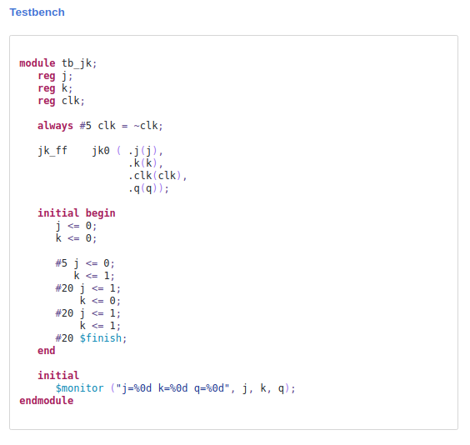

Simulation Waveform

Report Utilization Summary

